**Amendment 1**

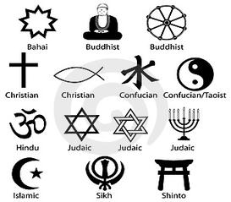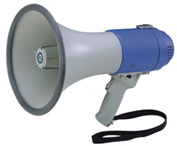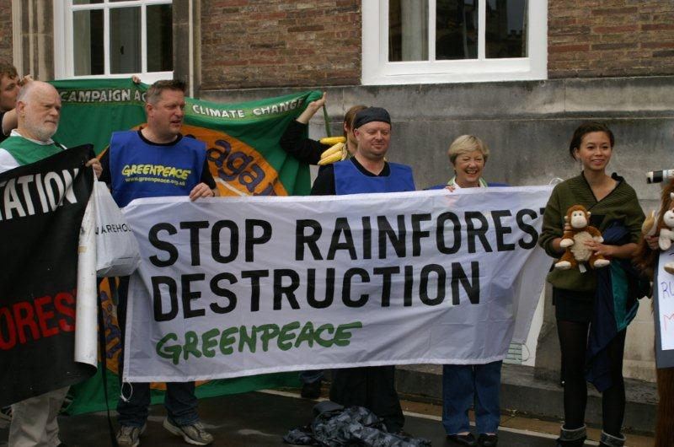

**KEY VOCABULARY**

**Prohibit:** to not allow

**Abridging:** to shorten by leaving something out

**Press:** things that are written

**Assemble:** to gather in one place

**Petition:** to make a request

**Amendment 2**

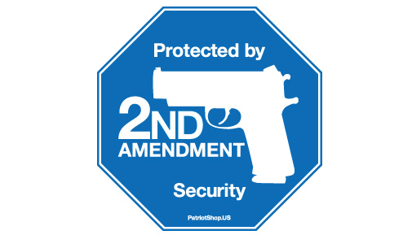

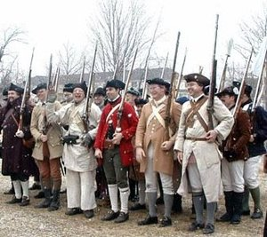



**Amendment 3**

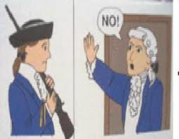

**KEY VOCABULARY**

**Quartered:** to live in a place

**Consent:** permission

**Prescribed:** to create a law





**Amendment 4**

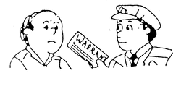

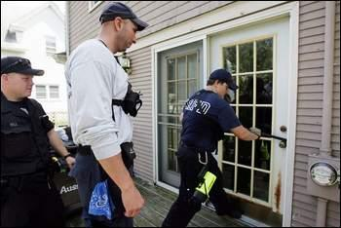

**KEY VOCABULARY**

**Secure:** safe

**Seizures:** to take something

**Violated:** to break

**Warrant:** document that gives permission

**Probable Cause:** reasonable grounds for belief

**Amendment 5**

**Amendment 5**



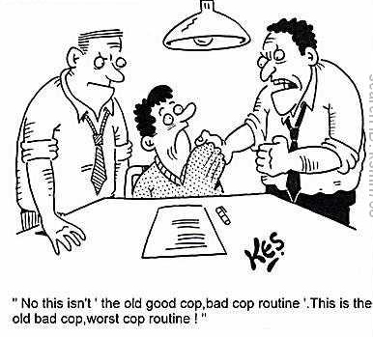



**KEY VOCABULARY**

**Indictment:** to bring a formal accusation against

**Jeopardy:** hazard or risk of loss

**Depriving:** to remove or lose

**Amendment 6**

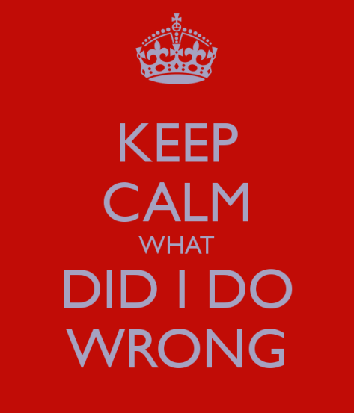



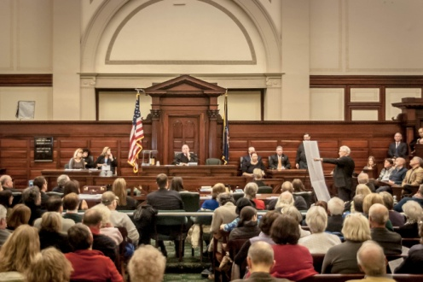

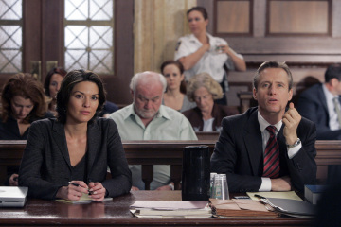

**KEY VOCABULARY**

**Prosecutions:** trials

**Accused:** to be charged with a crime

**Impartial:** to be fair

**Amendment 7**

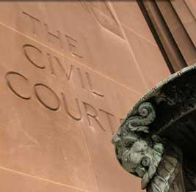

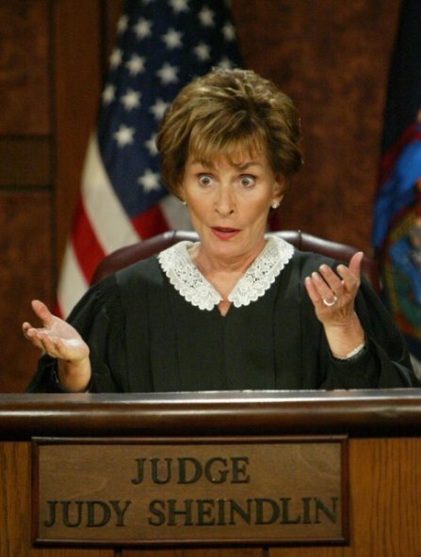

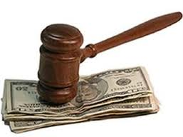

**KEY VOCABULARY**

**Suits:** to sue someone; have a lawsuit

**Controversy:** argument

**Amendment 8**

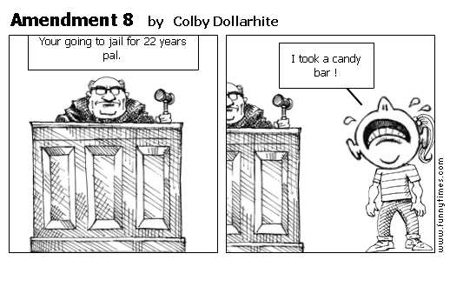

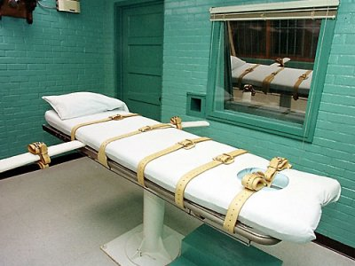

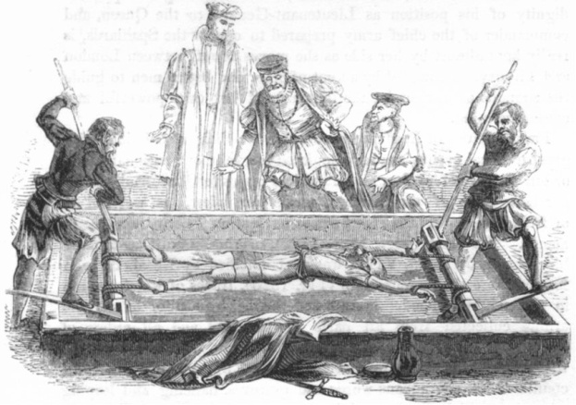

**KEY VOCABULARY**

**Excessive:** too much

**Bail:** property or money given as a guarantee that a person released from custody will return at an appointed time

**Amendment 9**



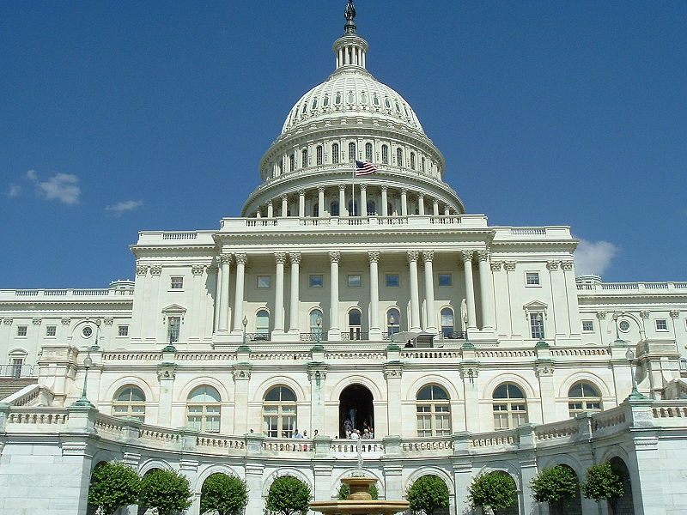

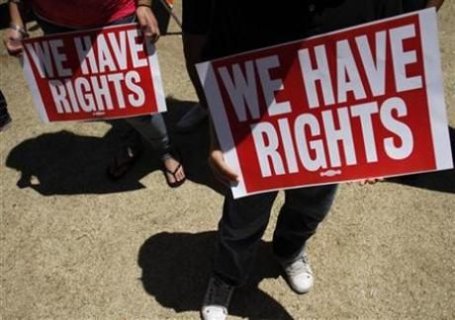

**KEY VOCABULARY**

**Construed:** interpreted

**Disparage:**  to belittle; to treat with disrespect

**Amendment 10**



**=**

**KEY VOCABULARY**

**Delegated:** to give power to the Federal government

**Prohibited:** not allowed

**Reserved:** to set aside power to the states

