Criminal v. Civil Trial Notes
- The Judicial Process is an ____________________________ 2 sides present their versions of a case and a jury/judge determines the resolution.
Civil Case the 2 sides = Plaintiff & Defense
  - Punishments= ________________awarded to winner for “_________________”
Criminal Case-Crime against _________________
- Criminal Law = Penal Law
  - 2 sides = ______________________________________ & ___________________________
  - Felony- committing a ____________________ resulting in a_____________ punishment. Robbery, Grand Theft Auto, Drug sales
  - Misdemeanor- committing a ___________________ usually resulting a __________punishment (fine or community service). Disorderly Conduct, trespassing, vandalism.
On your own: EXPLAIN 2 differences between a felony and a misdemeanor:

- Jury verdicts must be ________________________
- Punishments: _____________, community service, probation, ___________________________, death
CIVIL v. CRIMINAL Cases: Use the story from the PowerPoint to fill in the blank
CIVIL CASE: _________ vs. _________
Who are the Plaintiffs?_________________
Who are the Defendants?________________
Who do you think should win? Why

CRIMINAL CASE: ____________ vs. ____________
Who is the defendant?__________________
Who is the prosecution?_________________
Who do you think should win? Why
Write Civil or Criminal depending on the type of case:
- Slip and fall in a wal-mart because there is not “wet floor” sign.____________________
- Steal a Plasma TV from a Wal-Mart____________________
- Try to get sole custody of your children___________________
- Say something that is untrue about someone and ruin their reputation.__________________
- Kill a pedestrian in a crosswalk when you run a red light________________________
COMMON COURTROOM VOCAB!
- Probable Cause: what the prosecution must have to get a _______________for investigation.
- Plea Bargain: negotiation btw the prosecution and the defense to____________ court proceedings.
  - Prosecution might make a___________ to reduce the sentence if the suspect pleads guilty and/or if he testifies against others.
- Perjury: _____________ under oath
- “Burden of Proof:” it is the prosecution’s job to _________ that the defendant is __________ beyond a “___________________________________”
- Hung Jury: When the jury _________ reach a ___________________________verdictMistrial

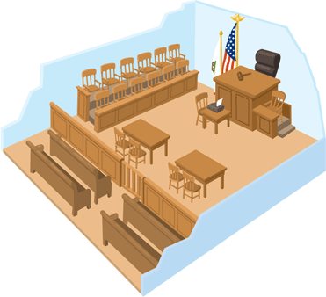

STEPS OF A CRIMINAL TRIAL! (A.P.I.A.T.S.)_______________________________________________
STEP: | What Happens

