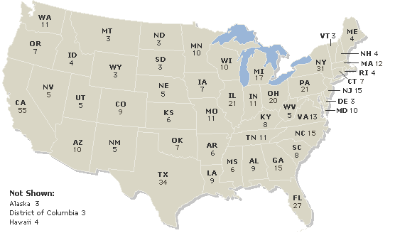

1. List 5 states with the most electoral votes (greatest to least)____________, ____________, ___________, ____________, ______________.

2. List 7 states have the least electoral votes (least to greatest)? _____________, ____________, _________________, _______________, _______________,_____________,____________.

3. During an election what does it mean when the media calls a state a “blue state” or a “red state”
  - Blue state:
  - Red state:
4. If you were running for president and polls showed that you were ahead by 20 percentage points in California and New York would you spend money campaigning there? Explain why or why not.

5. Do you think the winner-take all system is fair, why or why not?

→How we elect the President (Article II)
- Electoral College: This body is used to elect the _______________________.
    - Each state gets the # of ____________________ + # of ___________________
      - ____ NC representatives + ___NC Senators = _____ Electoral Votes
    - Winner Takes All: Whichever candidate wins the most popular_________ in that state will receive_____ the electoral votes for the state (Except in Maine & Nebraska)
    - In 2008, McCain won 49% of the popular vote in NC. Barack Obama won 50% of the popular vote in NC. Who received NC’s Electoral Votes? How many did he win?
_____________________________________ , ___________________________
    - There are a total of ____________electoral votes
    - You must win ______ electoral votes to win
    - If there is a _____ to _____ vote tie the House decides the President and the Senate decides the VP (________ Amendment)

→Why did the framers of the Constitution decide to create the Electoral College?
1. Federalism: The _______________________ wanted to make sure the ___________ still had power in the federal gov’t. The Electoral College is designed so that even ________ states can influence the outcome of an election.
  - Example: President Obama had to campaign in big states like Ohio and Florida, but he also had to campaign in NH which only has 4 electoral votes so that he would have at least 270 total on election day.
- Fear of a direct popular vote: The __________________ feared that a direct popular vote would be too much power in the hands of the ___________. They wanted _____________ to be able to make a thoughtful decision about who should be president.
  - Today, ___________________ vote the way the people in their state want them to.

→Criticisms of the Electoral College:
- _____________________________________ is unfair.
- Since all states have 2 Senators and at least 1 Rep that unfairly gives the states with ______________________________________ too much influence.
  - But then if small states didn’t have at least ___ electoral votes no candidate would ever pay attention to that state.
  - Example: In Wyoming there are _____________ people represented by each electoral vote. In California ____________ people are represented by each electoral vote.
  - But then if small states didn’t have at least 3 electoral votes no candidate would ever pay attention to that state.

