Illustrate a comic strip depicting the path to the presidency. Include a caption describing what is going on at each point.
1. | 2. | 3. | 4. | On the campaign trail…

→4-STEP PATH TO THE PRESIDENCY:
- Announce candidacy: make it public that you are running and begin to build __________________

- _____________ and Caucuses: Each ________ holds Republican and Democratic primaries or caucuses.
  - Primary: election where you vote for your choice to represent the party in the ___________________ (open or closed)
  - Caucus: ________________ where you _____________on who should represent the party in the ______________ election.
    - Primaries can be open or closed. Open means ______ registered voters can participate. Closed means only_______________________ can vote in the primary.
→What is the difference between an open and a closed primary?

- National Convention: _________________ for each party report at the end of the summer. This is where each party _______________ announces their _______________ for president.

- General Election: _______________ following the first Monday in November. Big night where you must win those _______ electoral votes!
  - During the__________________________ you can vote on a “_______________” or a “____________________”
    - Split: voting for Dems and Republicans.
    - Straight: just voting for _______ party

- Where does each party officially announce its candidate/nominee for the presidency?

- What is the difference between the Primaries and the General Election?

→On the campaign trail…campaigning happens THROUGHOUT the entire election cycle.
- Canvassing: where supporters go out and _________________________ and get people to vote.
- TV Commercials: reach the __________ people and can do good or bad.
- Retail Politics: REALLY meeting the voters and ___________________________.
- Polls: determine where _________________ __________________.
- Debates: a chance to meet opponent face to face and ____________ the issues.
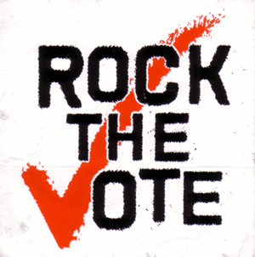
- Political Action Committee (PAC): raise ______ for candidates. Can be set up by the party or by _____________ or special _________________.
- Special Interest groups: Ex=labor __________, religious groups, ___________ groups, pro-environment, pro-guns etc. Raise __________ & ___________ for candidates who support their issues.

