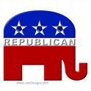
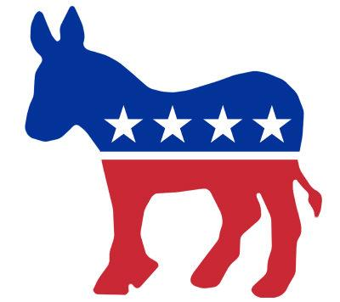

→ Political Parties
- Political Party: organized group of ___________ officials & supporters with a ____________, policies and _________________.
  - Parties have committees to organize at the precinct, county, state, and national levels (_____________________________)
  - Parties __________________candidates, raise _____ , and write __________________.
  - Primary purpose of the party → get their ________________ into elected __________ to shape the government according to their ___________.
- The party platform is what the party __________ for and the issues on its _________________

- Bi-Partisan: when two parties work together (Ex= recent economic bailout plan in Congress has Republican and Democratic supporters)
- Partisan: When the two political parties do not work together (Ex= Democrats and Republicans cannot agree on abortion bill.)

→Party Systems:
- ___________________: 3 or more parties
- One-party: ___________ dominant party
- Two party: power shifts back and forth between __________________.
  - Sometimes there can be ______________ which is doesn’t have power but can change election outcomes.

What type of system do we have in America? ________________________

→America’s Two Party System
The two major political parties in the US are the:
- ____________________________(Conservatives)
- ____________________________(Liberals)
You can register to vote as a Republican, a Democrat, or an __________________ (you don’t belong to either party).
→TRUE or FALSE: If I am registered as an independent that means I am a member of both parties.

→Political Spectrum
- Reactionary: Doesn’t support any ____________
- Conservative: little change, _____________________________, small gov’t
- Moderate: some _______
- Liberal: ______________, gov’t involvement to solve ___________________________.
- Radical: Revolution, wants _____________ change.

Warm Up: Are You A Democrat or a Republican?

Instructions: Read each statement. Circle whether you agree or disagree with each statement. If you are not sure, do not circle anything. When you are finished add up your number of agrees and disagrees in the box at the bottom.

1. Women have the right have an abortion if they so choose. AGREE DISAGREE
2. The gov’t should spend more money protecting the AGREE DISAGREE
environment and fighting global warming.

3. There should be limits on the amount and kind of AGREE DISAGREE guns that people can own.
4. Gays/lesbian couples should have the right to the same AGREE DISAGREE marriage benefits as heterosexual (“straight”) people.
5. Illegal immigrants should be allowed to stay in the U.S. AGREE DISAGREE
6. The military should receive less government funding. AGREE DISAGREE

7. The taxes of the rich should be raised to fund more programs. AGREE DISAGREE
8. Every American should have healthcare coverage. AGREE DISAGREE
9. Juveniles should not receive the death penalty for a crime. AGREE DISAGREE
10. Prayer should not be allowed in public schools. AGREE DISAGREE

Number of DISAGREEs
Number of AGREEs

PRACTICE QUESTIONS:
____1.The United States is an example of which party system?
a. one party system b. three-party system c. two-party system d. multi-party system
____2. Which political philosophy has historically advocated for additional funding for social programs?
a. Conservative b. liberal c. moderate d. reactionary

