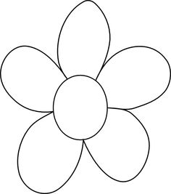

**Supreme Court Case Flowers**

Sort out the information you have learned so far into the different parts of the butterfly. Follow the example below.

How does this case impact society?

Pick another court case this relates to and explain how they relate.

What was the Supreme Court’s decision?

What amendment/principle does this court case involve?

Details of the case: Who is involved? What happened?

**CASE NAME**







