1. Before you read the documents, what is your answer to the following question:
Should U.S. companies use foreign sweatshops to make their products? Why or why not?

DOCUMENT 1
"Free Trade" and Sweatshops from www.globalexchange.org
The resurgence of the sweatshop can be directly linked to the expansion of corporate globalization. The sweatshop is both metaphor for and proof of the lawlessness and inequities of the new global economy. Every new sweatshop exposé raises new doubts about who corporate globalization is really benefiting.
WHAT IS A SWEATSHOP?
According to the US Department of Labor, a sweatshop is any factory that violates more than one of the fundamental US labor laws, which include paying a minimum wage and keeping a time card, paying overtime, and paying on time. It is also defined as any factory that does not pay its workers a living wage—that is, a wage that can support the basic needs of a small family.
WHAT KINDS OF ABUSES DO WORKERS FACE?
Workers at a plant in El Salvador, for example, say they are frequently required to work mandatory overtime as they sew jerseys for the National Basketball Association, according to the National Labor Committee, an anti-sweatshop group. That means they often put in 11-hour shifts, six days a week. If the workers at that factory refuse to work overtime, they lose a day’s pay. Workers making jeans in Mexico say that sometimes they are forced to work all night shifts, and are prevented from leaving the factory by armed security guards.
“I spend all day on my feet, working with hot vapor that usually burns my skin, and by the end of the day my arms and shoulders are in pain,” a Mexican worker, Alvaro Saavedra Anzures, has told labor rights investigators. “We have to meet the quota of 1,000 pieces per day. That translates to more than a piece every minute. The quota is so high that we cannot even go to the bathroom or drink water or anything for the whole day.”
Workers in at a factory in Mexico making collegiate apparel for Reebok and Nike have said managers there regularly hit them and slap them, according to the Workers’ Rights Consortium. Sexual abuse is endemic. Most garment workers are women, the vast majority of them young women in their teens or twenties who have left their homes for the first time so that they can earn money to send back to their families.
According to Human Rights Watch, in the maquiladoras along the US-Mexico border, factory managers who want to weed out pregnant workers so they can avoid having to pay maternity benefits force women workers to prove they are menstruating, a demeaning procedure that is against Mexican laws. Mandatory pregnancy tests are also common in El Salvador, and women who test positive are fired, also in violation of that country’s laws.
Workplace injuries and exposure to toxic chemicals also pose a daily risk to apparel workers. To prevent workers from stealing the items they are producing, factories sometimes lock the plant’s doors and windows, creating a fire hazard. In many factories, workers are not given masks to put over their noses and mouths, exposing them to tiny cloth fibers that get stuck in the lungs or dangerous glues.

2. What is a sweatshop?

3. What are the workplace conditions like in the factories? Give at least 2 examples to support your description.

4. Is the article for or against sweatshops? Why do you say this? Be specific.

DOCUMENT 2
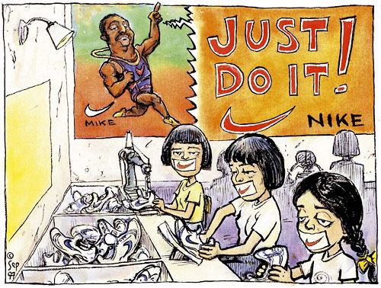
5. What is stuck across the girls mouths?

6. What is this cartoon saying about young girls in Nike factories?

DOCUMENT 3
Conditions in Sweatshops from a 20/20 Special Investigation. "Women Forced to Work". ABC News. 1 April 2000.
Sweatshops violate women's human rights throughout the world. Common abuses include low wages that fail to meet basic costs of living, substandard and unsafe working and living conditions, long hours of overtime for which employees are not compensated, and sexual harassment. In addition to these, women are often forced into indentured servitude. Lured by recruiters who promise wonderful opportunities in foreign lands, young women often pay thousands of dollars in recruitment and contract "fees", tying themselves to contractual obligations that can last for years. Because their wages are often only $.10 to $.20 per hour, the women may receive no wages for years as they attempt to pay off these debts. If the women try to return home without fulfilling their contractual obligations, they are often blacklisted, fined, or arrested. Sweatshops often fail to pay their employees on time, if at all. The workers, who are often unaware of their rights, have no choice but to continue to work because sweatshop managers threaten and punish them for insubordination.
Many of these factories, as well as the women's living quarters, are crowded, filthy, and rat-infested. They are located behind barbed wire fences that are monitored by armed guards. Not only are the women not allowed to come and go freely, but they are forbidden to have visitors. Thus, they are not given the opportunity to air their grievances to anyone who may be in a position to help them. Additionally, the women are always under the threat of corporal punishment. The women are verbally abused, spat on, and beaten. They are not allowed to take breaks or go to the bathroom during their shifts, and are fined if they do so. Female sweatshop employees are forced to endure numerous instances of sexual harassment. A 20/20 investigation in Saipan sweatshops discovered that pregnant employees were forced to have abortions in order to keep their jobs. These women are often faced with little if any choices. They are prohibited from unionizing, and face the loss of their job, physical abuse, or deportation if they try to better their situation.

7. What types of rights are withheld from women working in sweatshops?

8. Explain the women’s living conditions. What do the sweatshops remind you of? Why?

DOCUMENT 4

“Where Sweatshops Are a Dream” (2009) by Nicholas Kristof
-PHNOM PENH, Cambodia.
Mr. Obama and the Democrats who favor labor standards in trade agreements mean well, for they intend to fight back at oppressive sweatshops abroad. But while it shocks Americans to hear it, the central challenge in the poorest countries is not that sweatshops exploit too many people, but that they don’t exploit enough. Talk to these families in the dump, and a job in a sweatshop is a cherished dream, an escalator out of poverty, the kind of gauzy if probably unrealistic ambition that parents everywhere often have for their children.
“I’d love to get a job in a factory,” said Pim Srey Rath, a 19-year-old woman scavenging for plastic. “At least that work is in the shade. Here is where it’s hot.” Another woman, Vath Sam Oeun, hopes her 10-year-old boy, scavenging beside her, grows up to get a factory job, partly because she has seen other children run over by garbage trucks. Her boy has never been to a doctor or a dentist, and last bathed when he was 2, so a sweatshop job by comparison would be far more pleasant and less dangerous.
I’m glad that many Americans are repulsed by the idea of importing products made by barely paid, barely legal workers in dangerous factories. Yet sweatshops are only a symptom of poverty, not a cause, and banning them closes off one route out of poverty. When I defend sweatshops, people always ask me: But would you want to work in a sweatshop? No, of course not. But I would want even less to pull a rickshaw. In the hierarchy of jobs in poor countries, sweltering at a sewing machine isn’t the bottom.
I often hear the argument: Labor standards can improve wages and working conditions, without greatly affecting the eventual retail cost of goods. That’s true. But labor standards and “living wages” have a larger impact on production costs that companies are always trying to pare. The result is to push companies to operate more capital-intensive factories in better-off nations like Malaysia, rather than labor-intensive factories in poorer countries like Ghana or Cambodia.
Cambodia has, in fact, pursued an interesting experiment by working with factories to establish decent labor standards and wages. It’s a worthwhile idea, but one result of paying above-market wages is that those in charge of hiring often demand bribes — sometimes a month’s salary — in exchange for a job. In addition, these standards add to production costs, so some factories have closed because of the global economic crisis and the difficulty of competing internationally. The best way to help people in the poorest countries isn’t to campaign against sweatshops but to promote manufacturing there. One of the best things America could do for Africa would be to strengthen our program to encourage African imports.
Look, I know that Americans have a hard time accepting that sweatshops can help people. But take it from 13-year-old Neuo Chanthou, who earns a bit less than $1 a day scavenging in the dump. She’s wearing a “Playboy” shirt and hat that she found amid the filth, and she worries about her sister, who lost part of her hand when a garbage truck ran over her.
“It’s dirty, hot and smelly here,” she said wistfully. “A factory is better.”
9. What are some advantages to working in sweatshops?

10. Would you want to work in a sweatshop if you lived in third world country? Why or why not?

DOCUMENT 5 From Sweatshops and Third World Living Standards: Are the Jobs Worth the Sweat? (2004) by Benjamin Powell and David B. Skarbek
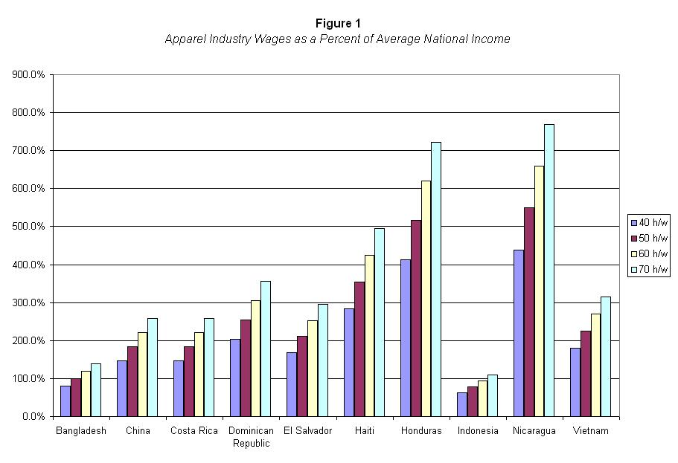
Figure 1 shows that apparel (clothing) workers working 70 hours per week make an average income that is higher than the average income in their country. Therefore, they make more money than the average worker in their country who has another job.
Example: Workers in Bangladesh that work 50 hours a week (red) make 100% more money per week than the average worker in that country.
11. Are there any countries listed where the wages earned in a sweatshop are lower than another job in that country?

12. What from the chart surprises you about the wages earned by workers in sweatshops?

DOCUMENT 6
Stossel in The Classroom video entitled “Sweatshops” https://www.youtube.com/watch?v=0VaHmgoB10E
13. According to the video, what is 1 argument FOR sweatshops and 1 argument AGAINST sweatshops?

14. What is your answer to the question now that you have read the documents: Should U.S. companies use foreign sweatshops to make their products? Why or Why not?

15. What are the pieces of the evidence from the documents you can use to back up your arguments?
1.

2.

3.

