Learning Menu- CLUB CONSTITUTION
Spend $80 = 100 points
Spend $70-$79 = 90 points
Spend $65-$69 = 80 points
Spend less than $65 = 65 points
Directions: for each section, choose which option(s) you would like to complete based on the directions. Student MUST complete the options that starred (*).
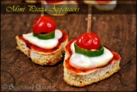Appetizer ($10)
- *Complete one of the seven vocab activities for the following words: Bill of Rights, amendment, ratify, quartering, due process, self-incrimination, double jeopardy, suffrage.
Side Dishes-CHOOSE TWO. ($15 each)
- Practice and present to the teacher the 10 hand signals that go with the Bill of Rights.
- Draw a chart with a symbol to represent each amendment. Charts should have no words (just numbers and symbols). Charts should look presentable enough to be hung in the classroom.
- *Create a CD, playlist, or soundtrack with 10 songs on it, each one representing 1 of the first 10 amendments. These can be real songs or titles you have made up. You must explain why you chose your song titles.
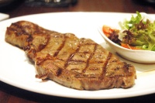Main Dish- PICK ONE ($30)
- Read the NY Times Upfront article “Who has the Right to Bear Arms?” Write a 3 paragraph persuasive speech arguing for or against gun control using at least three pieces of evidence from the article.
- Write 3 one paragraph (5-7 sentences) journal entries. Each journal entry should explain the way you have seen a different amendment play out in your personal life. For example, for one journal entry you could write about how the second amendment’s right to own a gun has impacted your community.
- Write 3 mini skits and perform them for the teacher/class. Each skit should show a different right being violated.

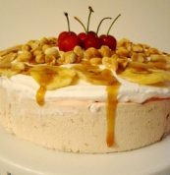Dessert-PICK ONE ($10)
- Create and perform, for the teacher, hand signals for Amendments 13, 14, 15, and 19
- Design a t-shirt or sneaker for each of the following amendments: 13, 14, 15, 19

