VOCABULARY HOMEWORK
For the assigned vocabulary words, you will select and complete one of the 7 options listed below. All completed vocabulary words in the activities chosen will be due the day of the vocabulary quiz (to be taken up before we take the quiz).
1. Riddles

Goal: To write a riddle using a specific set of vocabulary.
Instructions: For each vocabulary term assigned, create a riddle (must be at least 2 complete sentences) which allows a reader to easily guess the word it describes. Your riddles must be clear and solvable, and the assignment must give a clear overview of what each term means. You must provide an answer key as evidence that the riddles are solvable.

EX: Someone who was born in this country, or went through a special process. They are entitled to loads of rights and lead to our country’s success.
Answer: citizen

2. Graffiti
Goal: To creatively express oneself verbally in a public forum using specific vocabulary terms.
Instructions: Using a half sheet of paper as your graffiti space, use words, graphics and stylization to express your understanding of each vocabulary term assigned. Your “graffiti” must be creative, accurate, and appropriate for describing each word.

EX: For citizen

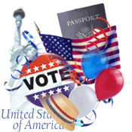Voting Rights 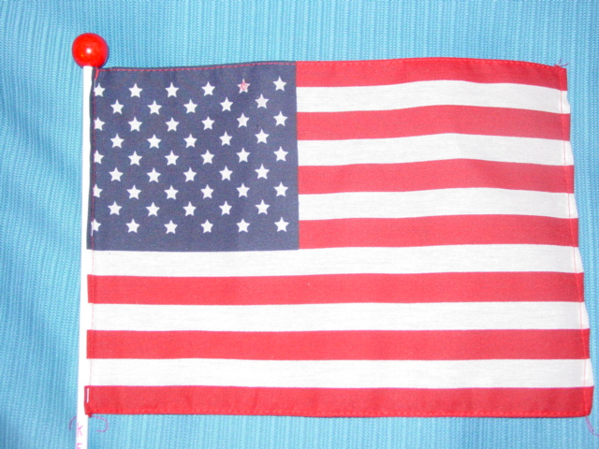 Naturalization 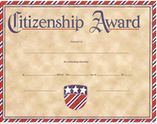 Responsibilities

3. Acrostics
Goal: To write acrostic poem using specific vocabulary terms.
Instructions: In an acrostic poem, each line is related to the word and starts with a letter of the topic word. Each line MUST be directly related to the topic. You may embellish your acrostic with artwork to better express your ideas, but the overall acrostic poem must give a clear and accurate overview of what each term means.

Defend the country
jUry duty
Taxes
ObeY laws

4. Children's Book
Goal: To write an illustrated child’s story using specific vocabulary terms.
Instructions: Write and illustrate a children’s book using all of the assigned vocabulary terms. Your story must: have a coherent and relevant plot, provide a basic definition for each term in your own words, and be presented in a way that would be understood by a child reader.

5. Concept Map

Goal: To create a concept map that defines and connects the main ideas outlined by specific vocabulary terms.
Instructions: You will begin by writing a definition of each vocabulary term in your own words and laying out each word with its definition on a page. You will then use arrows and written explanations to identify the relationships between each term. Your concept map should provide a clear idea of what each term means and how it is related to the other terms on your map.

Soil Citizen: Someone born in the U.S. Blood Citizen: Someone whose parents are citizens
Different types of citizenship

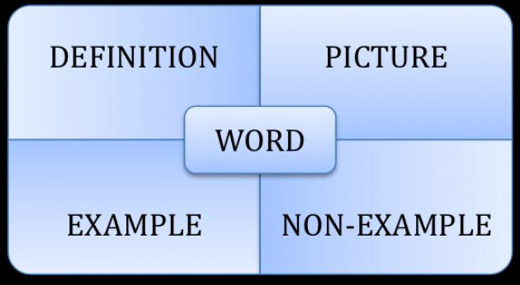
6. Frayer Model Flashcards

Goal: To create flashcards to use as a study tool for specific vocabulary terms. Instructions: On flash cards or notebook paper you will use the Frayer model to identify a definition, a drawing, examples/related words, and a personal connection for each word.
Personal connection

7. Cornell Notes

Goal: To create a set of notes to be a used as a study tool for specific vocabulary terms. Instructions: Using the Cornell notes format, outline the key points and definitions for each of the vocabulary terms assigned. Must use the Cornell notes format and complete sentences.

(Complete at least 3 from below)

Word Questions
Pictures
Key People/Places/Dates
Info from textbook
Personal Connections
Definition

